VOLUME 2: Technical Volume

Identification and significance of the problem

Problem statement
Special Operations Forces must perform in extreme environments and under high levels of stress for long durations. To ensure that the operators process information correctly and accurately and make the right decisions in a timely manner, the restorative effects of their sleep must be optimized via innovative therapies/interventions and technologies.

Scientific background and justification for the proposed therapies
Neuromodulation therapy is any therapy that directly modulates brain activity in a target area. Such therapies include non-pharmacological and pharmacological technologies that stimulate, or inhibit, brain regions resulting in demonstrated therapeutic benefits in various neuropsychiatric conditions. Investigation of their potential for improving sleep efficiency is warranted. Generally, non-pharmacological neuromodulation geared to a particular neurological or neuropsychiatric condition is linked to a medical device that is available for purchase. Many of the available devices are non-invasive and have a well-established safety record, with only very minor side effects. Consequently, particularly given the needs of military operations and a plethora of unknowns surrounding the connections between sleep patterns and waking performance, there is a strong rationale for testing such devices in sleep settings, in order to determine whether any neuromodulation device can be repurposed, either alone or in combination with other therapies, to the goal of decreasing sleep time while improving performance.
Pharmacological neuromodulation techniques include the use of L-Dopa, a precursor to dopamine that can cross the blood-brain barrier. Dopamine as a neuromodulator projects throughout the brain, particularly to the PreFrontal Cortex (PFC). The PFC includes attentional networks that are degraded with sleep loss. Thus, administering dopamine will support mental operations. (Kandel et al, 2012)
Non-pharmacological neuromodulation technologies include electrical (direct current) stimulation, magnetic stimulation, and ultrasound stimulation. Pharmacological neuromodulation technologies include orally ingested substances and substances absorbed. All of which warrant testing in the proposed pilot study, as they are associated with changes in brain activity and can be delivered non-invasively. Non-invasive delivery is an important factor, particularly in settings of military special operations.
Low intensity focused ultrasound (LIFU) and transcranial magnetic stimulation (TMS) are inherently non-invasive. Electrical neurostimulation targeting the central nervous system (CNS) classically has depended on surgically implanted electrodes. Such an approach entails a high frequency of a range of complications, such as bleeding, infection, subcutaneous fluid collection, plus hardware malfunctions such as migration and erosion of the implanted leads, and failure of pulse generators (Silberstein et al. 2012). While the proposed study will test only non-invasive modalities, the discussion in this proposal rests on a knowledge base resulting from clinical use of non-invasive (transcranial direct current stimulation [tDCS] utilizing transcutaneous electrodes) as well as invasive neuromodulation.
Attempts to utilize electrical current to provoke changes within the body date back to physicians of Antiquity, such as Hippocrates, Galen, and Scribonius Largus, who prescribed electrical discharges from torpedo fish (electric ray) to treat gout, headache, and even anal prolapse (Tsoucalas et al., 2014). Applied to the CNS, the modern age of neuromodulation began in the mid 20th century with treatments using electrical stimulation of the spinal cord to treat chronic pain, and from there neurosurgeons eventually went on to explore electrical stimulation of deep brain centers to alter electrical activity, underlying conditions ranging from major depressive disorder (MDD) to Parkinson disease (Dolhem, 2008). Over the decades, the precision of such therapies has ranged substantially from the notorious, early, anesthesia-less form of electroconvulsive therapy (ECT) to direct current delivered at particular combinations of voltage, current, and oscillation frequency through deep brain stimulation (DBS) electrodes placed surgically at precise anatomic locations, such as the subthalamic nucleus (Bot et al., 2018 X).
Both electrical stimulation and TMS affect electrical activity, and therefore chemical activity, in neurons, although the mechanism is different for electrical versus magnetic stimulation. In invasive electrical stimulation and in tDCS, direct current is delivered through electrodes causes depolarization of axons, and thus transmission of nerve impulse. With tDCS, the effect is possible because current reaches target peripheral nerves, such as branches of the trigeminal and/or occipital, or the cervical branch of the vagus nerve (Puledda and Shields, 2018 Barbanti et al., 2015). In the case of TMS, a magnetic field from a device induces electrical current in targeted brain sites, also resulting in neuromodulation, but with no need for physical contact between the device and the patient’s scalp. (Lan et al., 2017) In the case of LIFU, it has been hypothesized that sound waves may trigger axonal depolarization through some mechanism involving shear forces on tissues (Baek, 2017), or involving the microtubules or other components of the cytoskeleton (Hameroff, 2013). Whatever the mechanism, the procedure is safe, as the sound is at low intensity (equivalent to that used in diagnostic ultrasound (Baek et al., 2017), which entails such low risk that it is used routinely for obstetric evaluation.
In recent years, migraine disorder has been a setting in which both TMS (Lan et al., 2017) and tDCS have proven particularly beneficial. This is partially because testing has moved forward based on the fact that a very high number of migraine-afflicted people either do not respond adequately to medications, or do not tolerate side effects, particularly when it comes to triptans, the gold standard therapeutic drug category for migraine disorder (Loder, 2010). One approach to tDCS for migraine disorder has consisted of transcutaneous electrical stimulation of supraorbital branches of the trigeminal nerve. Known as external trigeminal nerve stimulation (eTNS), this FDA-approached migraine treatment can be achieved by way of a commercially available device called Cefaly® (CEFALY-Technology, Seraing, Belgium) that fits on the forehead, which anybody can purchase. More important to the proposed study, however, is a lack of serious side effects reported for the Cefaly device, and indeed for other non-invasive stimulatory devices that are on the market for migraine disorder.
One of the newest and most effective approaches to non-invasive electrical neurostimulation is combined stimulation of supraorbital nerves and branches of the occipital nerve. This strategy rests on a knowledge base of invasive electrodes, but recently has been developed in non-invasive form, using transcutaneous electrodes (Schenker, 2019). Based on work conducted with a device called Relivion, worn on the head and controlled through a mobile phone app, the treatment also has been evaluated in a pilot study suggesting that it can alter brain function sufficiently to mitigate MDD. Developed by Neurolief, LLC, the Relivion® is expected to undergo trials in additional neurological and neuropsychiatric settings, including attention deficit hyperactivity disorder (ADHD), and relevant to the proposed study, insomnia.
Another neurostimulation modality that is employed therapeutically in migraine settings is eNuera® (eNeura Ltd. London, United Kingdom) transcranial magnetic stimulation (TMS). This non-invasive technique involves application of a fluctuating magnetic field to the head and has been shown to be is a safe and effective over the past few decades. The magnetic field induces an electric current within neurons in the cerebral cortex and thalamocortical tracts. Effects of the induced current may include inhibition of thalamocortical nociceptive neurons and inhibition of depressive signals that otherwise spread through the cortex.
As for LIFU, studies suggest that transcranial ultrasound can alter mental states to the point of changing pain perception (Hameroff, et al. 2013). Moreover, experience with LIFU has reached a point that it has been suggested that it should be considered as an alternative, possibly a replacement, for TMS, DBS, and tDCS in certain neurological disorders, and as a means for stimulating targeted brain locations to provoke activity detectable in real-time via functional magnetic resonance imaging (fMRI) for the diagnosis of a range of disorders, such as mood disorders, obsessive convulsive disorder (OCD), cerebral vascular accidents, traumatic and hypoxic brain injury (TBI, HBI) Alzheimer disease, and altered states of consciousness (Baek et al., 2017).
Considering non-invasive neuromodulation devices in situations related to sleep and performance, recently, researchers in China have tested low frequency, single-pulse repetitive transcranial magnetic stimulation (rTMS) in the setting of primary insomnia (PI) (Song et al., 2019). In this small trial, which involved 20 patients and evaluated PI severity using Insomnia Severity Index (ISI), Pittsburgh Sleep Quality Index (PSQI), and the Epworth Sleepiness Scale (ESS), rTMS was given 14 days in a row at 1 Hz rTMS. The researchers found that, when focused on the right posterior parietal cortex, rTMS can improve PI symptoms, while reversing abnormal changes in time-varying electroencephalography (EEG), with changes persisting for one month.
In a trial run jointly between the Human Performance Wing at Wright Patterson Air Force Base and the Infoscitex Corporation, transcranial direct current stimulation (tDCS) directed at the dorsolateral prefrontal cortex (DLPFC) was tested as a fatigue countermeasure in comparison with caffeine gum (McIntire et al., 2017). Involving five groups of ten subjects each, the trial utilized a procedural game, a working memory task, a completed vigilance task, and a psychomotor vigilance task (PVT) as windows into attention accuracy and reaction time. The results indicated that tDCS effects are similar to those of caffeine, but longer lasting, suggesting that tDCS might be a better option.
As for using neurostimulation during sleep, a study published by German researchers in 2013 examined the effects of tDCS during sleep in schizophrenia patients (Göder et al., 2013). Researchers found that patients receiving tDCS at 0.75 Hz while sleeping showed improvement in sleep-associated memory consolidation. This result dovetails with previous research showing that tDCS applied to the prefrontal cortex of rats improves sleep-associated memory consolidation in connection with modulation of hippocampal - neocortical pathways (Marshall et al., 2005).
Although the influence of LIFU on sleep and the subsequent waken state is largely terra incognita, the consideration that is being given to the technique as a potential therapy in the various clinical settings mentioned above warrants its investigation as a sleep modifier. Dovetailing with this idea, a newly published study involving macaque monkeys has revealed that LIFU can alter activity in the brain’s anterior cingulate cortex, with resulting behavioral effects in the form of changes in the decision-making process (Fouragnan, et al., 2019). Although not yet in the formal scientific literature, recently, at the Transformative Technology Conference, a neuroscientist suggested that LIFU and other neuromodulation modulations might be useful to help people obtain the “higher states of consciousness” that are desired during meditation practices (Sanguinetti, 2018).
To be sure, it may take years for a traditional knowledge base to accumulate supporting the application of LIFU, as well as tDCS and TMS to improve the efficiency of sleep, to enable better performance with less sleeping time. However, given the needs of military special operations, the benign nature of all the aforementioned neuromodulation techniques, and the availability of off-the-shelf devices, we believe that an empirical approach that jumps directly into clinical testing is warranted and that chances are good that such a study will reveal one or more therapies worthy of more extensive investigation.

Overview of the three-phase program and key outcomes
The key outcomes of the three-phase program are outlined below:
Phase I: Feasibility study: We propose to conduct a feasibility study to assess which modality has the most efficacy for increasing the recuperative effects of less sleep. The main outcome will be a scientifically justified recommendation for further study and prototyping along with a preliminary system design document.
Phase II: Prototype development: We will develop and demonstrate a prototype system based on the results of the feasibility study. The computerized prototype system will implement the most feasible and promising solution in an appropriate hardware/software setup.
Phase III: Dual-use applications: The main outcome will be a system ready for military and civilian use. We will propose the solution to the Army through the Office of the Deputy for Acquisition of the US Army Medical Research and Materiel Command, and to the Navy through the Acquisition & Analytics Directorate of the Navy’s Bureau of Medicine and Surgery contracting program, under the Naval Medical Logistics Command, as well as other relevant directorates. We will also introduce the system to law enforcement agencies, NASA, and major athletic organizations such as the NFL, MLB and others.

Phase I technical objectives
We will evaluate five therapies and test their effects on sleep and performance. We believe that these therapies show promise to accelerate the restorative effects of sleep, which is a major goal of the program. The specific objectives of Phase I are:
- Obtain IRB approval for the proposed human subject study.
- Administer the proposed therapies and collect performance data.
- Evaluate the performance data by quantitative statistical methods and select the most promising therapy or combination of therapies to be investigated in Phase II.
- Develop an initial system design to administer the selected therapies in extreme environments in which SOF operators typically perform.

Phase I statement of work

Work plan
The Phase I project timeline is shown in Figure 1, followed by a detailed description of tasks.
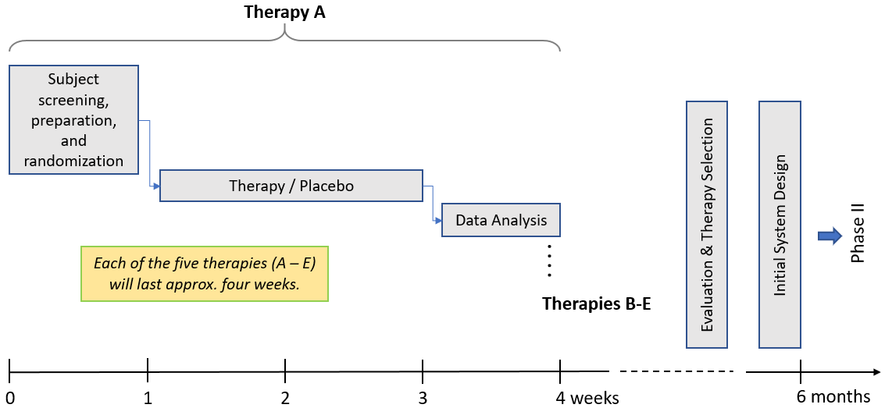
Figure 1: The Gantt chart of the Phase I project.

Task 1 – Recruitment and IRB approval
For this proof of concept Phase I study, 10 healthy adult participants (n=10) would be recruited from the greater Spokane, WA, area. The protocol will be reviewed and approved for the use of human subjects by the Washington State University Institutional Review Board (IRB) before the study would be conducted. Mgenuity’s Federalwide Assurance (FWA) for the Protection of Human Subjects certificate lists Washington Ste U IRB #1 - Behavioral & Biomedical as a designated IRB.
Mgenuity Corporation: FWA#: FWA00028277 Expires on 06/20/2024
Washington State University: FWA#: FWA00002946 Expires on 01/09/2023
Washington Ste U IRB #1: HHS IRB#: IRB00000449 Expires on 11/15/2020

Task 2 – Therapy administration and performance data collection
The study would be a randomized, counterbalanced study with a washout period of 5 days per experimental phase and a baseline and post experimental phase. Participant sleep would be confirmed as normal (7-8 hours) on the baseline days and sleep would be measured continuously with actigraphy (Philips Respironics, Bend, OR) throughout the study which would begin 3 days prior to the experimental phase and end 5 days after the experimental phase. We would conduct an exploratory data analysis to develop hypotheses regarding the relationship between the variables of interest followed by formal, confirmatory statistical testing.
To minimize the number of needed subjects, experimental and control conditions will be tested in a way that allows subjects to serve as their own controls. Testing is pre and post one night of sleep restriction (5 hours time in bed (TIB)) with therapy versus one night of sleep restriction (5 hours time in bed (TIB)) without therapy versus one night normal night sleep (8 hours TIB) with washout nights in between. For each therapy:
- N = 10 counterbalanced
- Administered for the whole night of sleep restriction
- All 10 subjects run in two conditions - Placebo or sham
- Testing – Psychomotor Vigilance Test (PVT), go no-go task with reversal
- Testing is pre and post one night of sleep restriction (5 hours time in bed (TIB)) versus normal night sleep (8 hours TIB)
Performance will be measured by the psychomotor vigilance test (PVT) which is among the most widely used measures of behavioral alertness in sleep research as a result of its high sensitivity to sleep deprivation and its psychometric advantages over other cognitive tests, with virtually no learning effect. A significant body of research correlates sleep deficit with deteriorated alertness, slower problem-solving, and declined psycho-motor skills.
The PVT is a 10-minute reaction time task that measures response time to a stimulus. Either the Joggle Research Application PVT or the NASA PVT and go no-go task would be used. The go no-go task would include a reversal aspect that tests mental flexibility.

Table 1: The five therapies administered and evaluated during Phase I.

Therapy | Rationale and details
Therapy A: L-Dopa combined with Rasagiline | L-Dopa drives Dopamine synthesis and Rasagiline inhibits Dopamine degradation - in combination increases the Dopamine available for neuromodulation. L-Dopa and Rasagiline or Placebo are administered both an hour before bedtime (1 tablet includes 50 mg Carbidopa 200 mg L-Dopa for extended release, 1 tablet includes 25 mg Carbidopa 100 mg L-Dopa for short acting release, and 1 tablet includes 1 mg Rasagiline) and in the morning the same dosing protocol following a night of restricted sleep. Thus, the participants will get three pills one hour before bed and 3 pills in the morning.
Therapy B: Neurolief Relivion® | Non-invasive, multichannel Transcranial Direct Current Stimulation (tDCS) device worn on head.
Therapy C: Cefaly® | Non-invasive, Transcranial Direct Current Stimulation (tDCS) device worn on the forehead and the bridge of the nose.
Therapy D: eNeura Transcranial Magnetic Stimulation (TMS) | Non-invasive magnetically induced stimulation of deep brain centers.
Therapy E: Low intensity focused ultrasound (LIFU) | Non-invasive ultrasonic stimulation of brain centers.

Task 3 – Evaluation and therapy selection
In a paired t-test paradigm, the effect sizes of 5-10 different 10-minute PVT performance outcomes will be calculated for PVT metrics related to lapses and to measures of psychomotor speed, i.e., mean 1/RT (response time) and mean slowest 10% 1/RT. Response times >500ms will be interpreted as omission (lapse). Research indicates that these metrics usually have high effect sizes in contrast to PVT mean and median RT outcomes, which scored low to moderate effect sizes influenced by extreme values. (Basner & Dinges, 2011). The effect sizes for each subject and each therapy will be reported along with other parameters we may deem important (e.g., age, gender, weight). We will make a recommendation for the most promising therapy or combination of therapies to be investigated further in Phase II. A summative final report will be submitted along with a video demonstration.

Task 4 – Initial system design and final report
We will develop an initial system design to administer the selected therapies in extreme environments in which SOF operators typically perform. The system is envisioned to have hardware, software, and communication components. Although Mgenuity has seasoned electrical engineers and software developer, we may hire a hardware/electronics engineer in Phase II to assist with the prototype development. The initial design will be presented as a Functional Specification Document and a System Requirements Specification (SyRS) document.

Risks and risk mitigation strategies
After the feasibility study has been completed, the potential risks and mitigation strategies will be assessed in a traditional Risk Assessment Matrix that will contain the impact (low, medium, high) and probability (low, medium, high) of each risk factor, as well as relevant mitigation strategies. Risk mitigation strategies will be summarized in the final report and will become a part of the Phase II plan.

Related work

Directly related work
Text… Amanda: maybe two paragraphs about the current work going on in your lab.

Previous work not directly related to the proposed effort but similar
Table 4: Related work in collaborative computing prepares us for this project
Related Work | Short Description | Client | Date of Completion
DARPA Contract No. N66001-96-C-8510 and US Army CECOM Contract No. DAAB07-00-D-G504 | A. Medl and S. Juth developed collaborative software/hardware system for mission planning which is an excellent baseline for Phase II of this project. | DARPA  US Army CECOM | July 1996 – Aug 2002

Relationship with future research or research and development
The success of this project is envisioned to facilitate our development of sleep enhancement systems in other national defense areas, including but not limited to the Navy, Air Force, Army, NASA, and law enforcement agencies. Civilian applications will certainly include sports organizations. The intellectual property and know-how collected during this project will be instrumental in the development of these future solution.

Commercialization strategy
The system developed during this R&D is intended primarily for USSOCOM and other branches of the US military. We will propose the solution to the Army through the Office of the Deputy for Acquisition of the US Army Medical Research and Materiel Command, and to the Navy through the Acquisition & Analytics Directorate of the Navy’s Bureau of Medicine and Surgery contracting program, under the Naval Medical Logistics Command, as well as other relevant directorates. If the system does not become classified, we also plan to introduce it to law enforcement agencies, NASA, and major athletic organizations such as the NFL, MLB and others. The commercialization efforts will be led by Daniel Haughton, who has a significant experience in business development.

Key personnel
DAVID WARMFLASH, MD – Principal Investigator
Project role: Leads the feasibility study in Phase I and coordinates the efforts with the State University of Washington team. Prepares the final report. Leads the prototyping in Phase II.
Qualifications and expertise: Consultant for Neurolief, LLC as Medical Officer, Medical Communications, Neurology Research. Topic: Wearable non-invasive neuromodulation device for neurological and neuropsychiatric disorders, including migraine, mood disorders, and ADHD. Contributing author for multiple outlets, including Medscape, Genetic Literacy Project. Biotech/Medical Advisory Board member for Lifeboat Foundation. David received his BS in zoology from the University of Massachusetts/Amherst in 1989 and his MD from Tel Aviv University in 1996. He conducted his postdoctoral research in radiology and radiation oncology at the University of Pennsylvania and was a fellow at NASA’s Astrobiology Institute and Ashton Graybiel Laboratory. David was the lead medical expert on Mgenuity’s HoloXplorer project that developed holographic applications for the Yale School of Medicine.
Selected Relevant Publications:
- Betts, B. H., D. Warmflash, R. Fraze, L. Friedman, et al. Viability and growth of species of Archaea, Bacteria, and Tardigrada following 16 days in Low Earth Orbit aboard the STS-134 Space Shuttle Flight. Accepted for publication in Astrobiology 2019.
- Betts B, Nye B, Fraze B, Warmflash D, Svitek T, and Friedman L. (2012) The Phobos Life Biomodule: A Rugged, Multi-Sealed Design for Space Biology Experiments. International Astronautical Federation Congress Journal.
- Warmflash D., Chu H., Siefert J., and Fox G.E. Life Detection Using Glucose and Tetrasaccharide Enantiomer Pairs. Astrobiology 9(3): 297-303, 2009.
- Warmflash D, Larios-Sanz M, Jones J, Fox GE, and McKay DS. Biohazard Potential of Putative Organisms for Missions to Mars. Aviation, Space, and Environmental Medicine 78(4, section II): A79-A88, 2007.
- Larios-Sanz M, Kourentzi KE, Warmflash D, Jones J, Willson RC, Pierson DL, and Fox GE. 16S rRNA Beacons for Bacterial Monitoring in Craft and Habitat Modules in Human Space Missions. Aviation, Space, and Environmental Medicine 78(4, section II): A43-A47, 2007.
- Nawarathna D, Miller JH Jr., Claycomb JR, Cardenas G, and Warmflash D. Harmonic Response of Cellular Membrane Pumps to Low Frequency Electric fields. Physical Review Letters 95(15):158103, 2005.
GREG BELENKY, MD, FAPA – Co-Investigator
Project role: Co-Leads the therapy administration (Phases I and II).
Qualifications and expertise: Gregory Belenky is a research professor at Washington State University Spokane, where he launched the Sleep and Performance Research Center. Before coming to WSU Spokane, Dr. Belenky held the rank of Colonel in the U.S. Army Medical Corps, and served as Director of the Division of Neuroscience at the Walter Reed Army Institute of Research (WRAIR). Dr. Belenky’s research ranges from basic to applied and includes sleep, sleep deprivation and continuous operations; combat stress reactions and post-traumatic stress disorder; and the neurobiology of human behavior and adaptation. His work has been funded by the Department of Defense, the Department of Transportation, the Department of Labor, and several other sources. During Dr. Belenky’s stewardship at WRAIR, the program grew in national and international stature, producing groundbreaking research and publications in the areas of brain imaging in sleep and sleep deprivation, the performance effects of stimulants and sleep-inducing drugs, and the effects of chronic sleep restriction on performance.
Dr. Belenky received his MD degree from Stanford University, studying with the “father of sleep research”, Dr. William Dement. He holds a BA degree in psychology from Yale University. He is a Fellow of the American Psychiatric Association and a member of the American Academy of Sleep Medicine, the Sleep Research Society, and the European Sleep Research Society; and he served on the Board of Directors of the National Sleep Foundation.
Dr. Belenky pioneered the development of non-invasive ambulatory sleep/wake monitoring techniques and Palm OS-based performance tests such as the Palm Pilot psychomotor vigilance task, for the first time making possible studies of sleep and performance in normal and clinical populations going about their daily lives. He holds several patents on the Sleep Watch actigraph. It is the core of the U.S. Army’s developing Sleep Management System, a tool to enable commanders to effectively manage sleep to sustain performance in the operational environment. During the Gulf War (1990–1991), Dr. Belenky served as regimental psychiatrist for the U.S. Army’s Second Armored Cavalry Regiment.
In addition to authoring over 100 journal articles, book chapters, and technical reports, Dr. Belenky has edited two books on combat psychiatry: Contemporary Studies in Combat Psychiatry (Greenwood Press, 1987) and The Gulf War and Mental Health: A Comprehensive Guide (Praeger Press, 1996).
Relevant Publications: https://medicine.wsu.edu/overview/faculty-and-staff/gregory-belenky/
AMANDA LAMP, PhD, MS – Co-Investigator
Project role: Co-Leads the therapy administration (Phases I and II).
Qualifications and expertise: Amanda Lamp is a research assistant professor at Washington State University Spokane in the Occupational Sleep Medicine Group in the Sleep and Performance Research Center and the Elson S. Floyd College of Medicine. Dr. Lamp’s academic background includes Neuroscience (BS) with a Psychology minor, Prevention Science (MS, PhD), and over 7 years working with one of the leading occupational sleep medicine scientists, Dr. Gregory Belenky, on sleep and performance research. This background has allowed Dr. Lamp to establish expertise in the fields of sleep and performance, along with expertise in prevention and intervention studies and programs. Dr. Lamp is a member of the Sleep Research Society and currently serves on the Fatigue Countermeasures Working Group that includes a select group of aviation and scientific experts and in November 2018 published a paper on controlled rest guidance for aviation titled Controlled Rest on the Flightdeck: A resource for operators.
Selected Relevant Publications:
- Belenky G, Lamp A, Hemp A, Zaslona J (2013) Fatigue in the workplace. In Bianchi MT (Ed.), Sleep Deprivation and Disease, New York: Springer, pp. 243-268.
- Lamp, A., Chen, J., McCullough, D., Belenky, G. (2018) Equal to or better than: The application of statistical non-inferiority to fatigue risk management. Accident Analysis and Prevention, https://doi.org/10.1016/j.aap.2018.01.020
- McDonald J, Potyk D, Fischer D, Parmenter B, Lillis T, Tompkins L, Bowen A, Grant D, Lamp A, Belenky G (2013) Napping on the Night Shift: A study of sleep, performance, and learning in physicians-in-training. Journal of Graduate Medical Education, 5(4): 634-638.
- Gander PH, Wu LJ, Van den Berg M, Lamp A, Hoeg L, Belenky G (2018) Fatigue Risk Management Systems. In Kryger, M., Roth, T. and Dement, W.C. (Eds.) Principles and Practice of Sleep Medicine, 6th Edition, pp. 697-707.
- Lamp A, McCullough D, Chen J, Brown R, Belenky G (2019) Pilot Sleep in Long-Range and Ultra-Long-Range Commercial Flights. Aerospace Medicine and Human Performance, 90(2): 109-115.
- Fatigue Countermeasures Working Group (including Lamp A). “Controlled Rest on the Flight Deck: A resource for operators.” Flight Safety Foundation. Nov 2018. Full text link: https://flightsafety.org/wp-content/uploads/2018/11/Controlled-Rest.pdf
ATTILA MEDL, PhD, MBA – Co-Investigator
Project role: Leads the initial system design (Phase I), prototype development (Phase II), and commercialization efforts (Phase III).
Qualifications and expertise: Hands-on management of software companies and high-technology government programs. MBA from Montclair State University (NJ) and a PhD in Computer Science & Engineering from the Technical University of Budapest. At Rutgers University Attila worked for National Medal of Science (’96) recipient James L. Flanagan as a key researcher in two multi-million-dollar DARPA/NSF/CIA/NSA research projects that focused on the use of artificial intelligence for natural modes of human-computer communication (speech, gaze, gestures, tactile). At Rutgers/Robert-Wood-Johnson Medical School he developed a system that analyzed intracranial brain signals during brain surgery for Parkinson’s patients. In 2000 Attila co-founded Voxline Inc., a mobile technology software company that was acquired by Norwegian wireless carrier Telenor in 2006. As Mgenuity’s CEO, Attila dedicates all his time and effort to the company.
Selected Relevant Publications:
- Lehmann, R.M.; Micheli-Tzanakou, E.; Medl, A.; Hamilton, J.L.: Quantitative On-Line Analysis of Physiological Data for Lesion Placement in Pallidotomy. Stereotactic and Functional Neurosurgery Vol.75 No.1, pp.1-15. (2000)
- Marsic, I; Medl, A.; Flanagan, J.L.: Natural Communication with Information Systems. (Invited paper). Proceedings of the IEEE, Vol.88, No.8, pp.1354-1366. (Aug. 2000)
- Medl, A., Flotzinger, D.: Hilbert-transform based predictions of hand movements from EEG measurements. Engineering in Medicine and Biology Society, 1992, vol. 14. In: Proceedings of the Annual Int’l Conf. of the IEEE, vol. 6 (Paris, France, October 29-November 1, 1992).
- Comaniciu, D., Meer, P., Medl, A., Foran, D.J.: Bimodal System for Interactive Indexing and Retrieval of Pathology Images. IEEE Proceedings on Computer Vision. pages 76-81. (1998)
- Akay, M; Marsic, I., Medl, A.; Bu, G.: A system for medical consultation and education using multimodal human/machine communication. IEEE Transactions on Information Technology in Biomedicine 2(4): 282-291. (1998)
Commercialization results: As the co-founder of Voxline, Inc., Attila was the driving force behind the 100,000+ subscriber WebTap mobile advertising platform that reached a yearly revenue of $1.4 million in less than two years after product launch. Voxline was acquired in 2006 by Norwegian wireless carrier Telenor. Commercialization efforts for the MathBrainius educational software developed under NSF SBIR Grant #1632573 has started in June 2019.
CHRISTOPHER RHOADS, PhD – Statistician and Evaluator
Project role: Quantitative efficacy evaluation (Phases I and II).
Qualifications and expertise: Dr. Christopher Rhoads received his Ph.D. in Statistics from Northwestern University (NU) in 2008 and is currently Associate Professor and head of the Research Methods, Measurement and Evaluation program within the Department of Educational Psychology in the Neag School of Education at the University of Connecticut.
Relevant Publications:
- Rhoads, C. (2017). Coherent power analysis in multi-level studies using parameters from surveys. Journal of Educational and Behavioral Statistics, 42(2), 166-194.
- Louie, J., Rhoads, C, and Mark, J. (2016). Challenges when using the Regression Discontinuity Design in educational evaluations: Lessons from the Transition to Algebra study. American Journal of Evaluation, 37(3), 381-407.
- Rhoads, C. (2014). Under what circumstances does external knowledge about the correlation structure improve power in cluster randomized designs? Journal of Research on Educational Effectiveness, 7(2), 205-224.
- Rhoads, C. (2011) The Implications of Contamination for Experimental Design in Education Research. Journal of Educational and Behavioral Statistics,36(1), 76-104. Republished in Coryn, C.L. and Westine, C. (2015) . Contemporary Trends in Evaluation Research. Thousand Oaks, CA: Sage Publications.
DANIEL HAUGHTON, MBA – Business Development Director (Phase III only)
Project role: Will lead sales and marketing in Phase III.
Qualifications and expertise: Dan received his BA from Vanderbilt University and his MBA from Harvard Business School. He was Senior Vice President for Strategic Planning and Marketing at Kidder Peabody for 8 years in New York and served as First Vice President for Marketing Services in the Private Client Group at Merrill Lynch. Dan helped launch two technology companies that developed specialized and innovative Internet software products.

Foreign citizens
All investigators are citizens of the USA. The only investigator with a dual citizenship is Attila Medl; he is a citizen of the USA and Hungary.

Facilities and equipment

Mgenuity’s instrumentation and physical facilities
Mgenuity currently rents a 250 sqft office at 475 Wall Street, Princeton, NJ 08540. The building has 4 conference rooms and the possibility to rent additional office space as needed in Phase II.
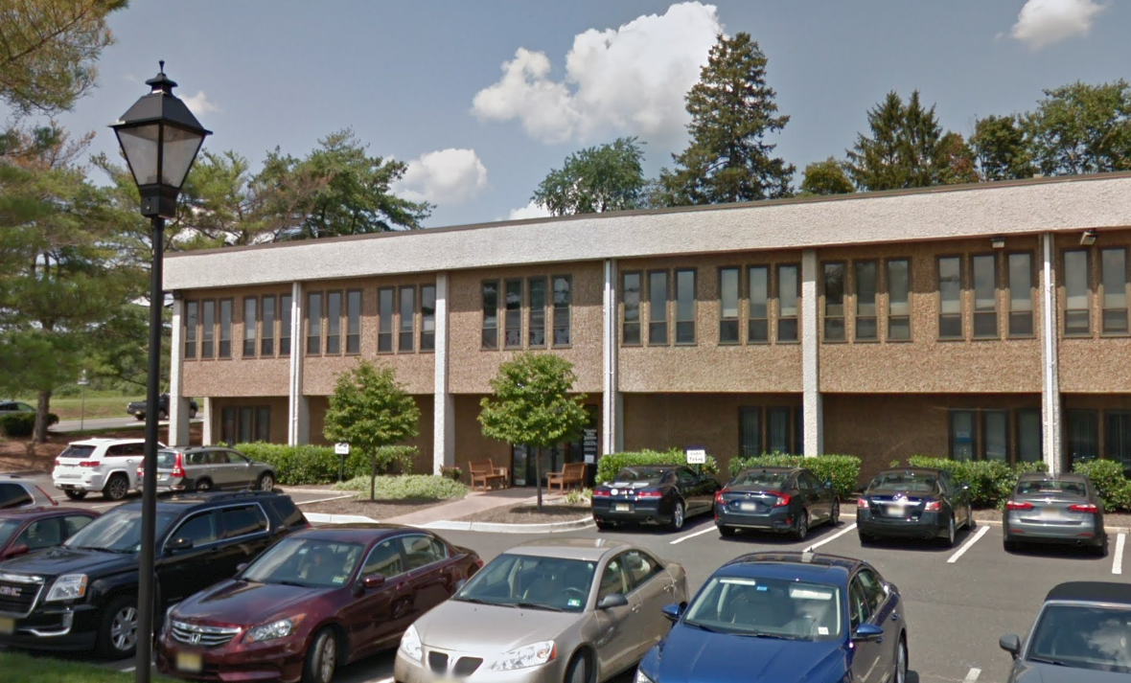 | 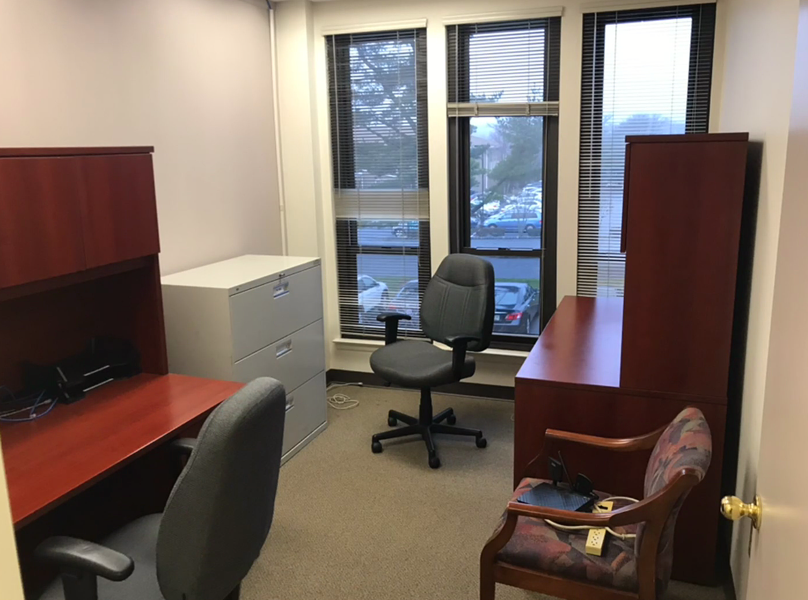
Figure 10: Mgenuity’s office space at 475 Wall Street in Princeton, NJ
The company currently owns the necessary equipment and software:
- 3 high-powered Dell development workstations (Win 10) for coding and Unity 3D development
- 3 Apple iMac computers for coding, video and audio editing, 3D rendering, and Unity 3D development
- 1 Dell XPS-13 touchscreen laptop for demonstration purposes
- 2 Apple MacBook Pro laptops for software development and testing
- Access to a Source-Connect-certified voice recording studio (for HoloLens voiceovers)

WSU Sleep and Performance Research Center’s instrumentation and facilities
Text … Amanda

Subcontractors and consultants
The following organization will be a subcontractor on the grant.
Occupational Sleep Medicine Group
Sleep and Performance Research Center
Department of Medical Education and Clinical Sciences
Elson S. Floyd College of Medicine
Washington State University Spokane

Prior, current, or pending support of similar proposals or awards
No prior, current, or pending support for proposed work.

Refences cited
The references are available at the following URL: https://www.medl.us/mgenuity/USSOCOM/References.pdf

